Warners Bembridge Isle of Wight April 2026

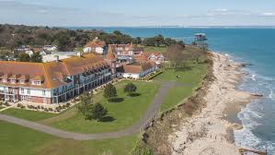

Dear Member

A holiday (4 nights, 5 days) is being arranged at Bembridge in the Isle of Wight (IOW) from 20 April 2026 to 24 April 2026.

The cost for those sharing a room will be £390 per person and for those not sharing a room the cost will be £440 per person.

The costs quoted above include all coach travel, the 4 night stay and breakfast and dinner at Warner, the ferry crossing, and 2 'day' trips (not obligatory) to destinations within the IOW. Our blue badge guide Kim will not be joining us.

Pick up points will be the usual Hitchin, Letchworth and Stevenage.

A £10 deposit is required per person. I need to know by 17 July 2026 at the very latest **(or preferably immediately)** if you will be joining us for this holiday.

You can let me know by telephone (07799 787116 or 01462 620317) or by email ([adam@kuzminski.co.uk](mailto:adam@kuzminski.co.uk)). **Do not reply to Ruth.**

I look forward to hearing from you.

Adam